Software Development V

CSE - 3200

SUBMITTED BY:

Submitted to:

Golam Rahman Tushar, Lecturer, CSE , AUST

**Biozid Niloy**

14-02-04-070

**Samin Shahriar Tokey**

14-02-04-066

**Naimul Haque**

14-02-04-080

Bad Planet

**Project Name: Bad Planet**

**Project Type : 2d Platformer Game**

**Introduction**

This is a 2D Platformer game which is powered by Unity game engine and will be written in C# featuring cool outer 2D graphics.

**Game Features**

There’s going to be a simple but good looking main menu GUI from where user/player can access the others states.

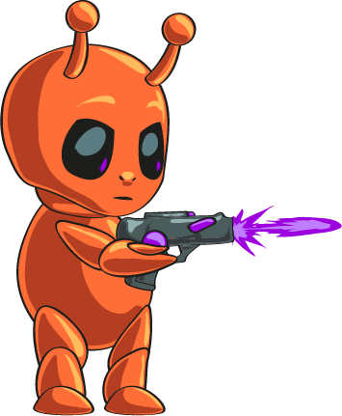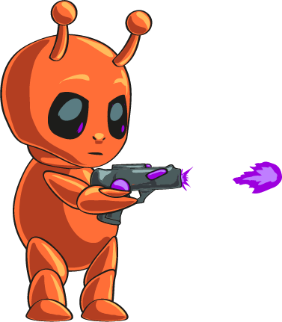

We will try to add a beautiful simple animation. There will be an option state in the Main Menu where we can toggle various settings of the game.

The character is an Alien who got stuck in a planet where there are other aliens who try to invade the alien’s child ship. Alien fight back and try to find his lost ship to get back to his own planet.

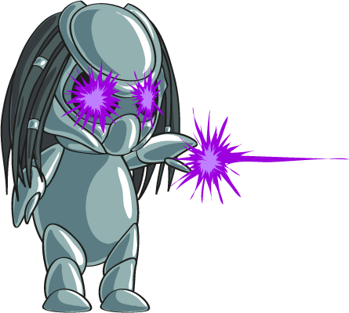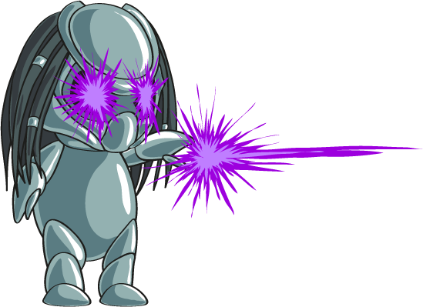

There might be various unlockable features and gadgets that be used later in the game.

There is going to be immersive sound effects, music and visual effects.

The game might have a high score state. If any players top the high score his score will be used to replace the previous one. We will use database to store and sort the scores!

We will try to implement SOLID properties that are taught in lab, so that the game can be updated, and implemented in a systematic way.

* Collect Crystals for health
* Spend crystals to reincarnate and increase lives
* Destroy enemies to score points
* Avoid free and use provided probes to unlock levels

**Softwares to be Used**

* Microsoft Visual Studio 17
* Unity 5
* Android SDK
* JVM
* Mono Developer
* Adobe Photoshop CC
* Adobe Lightroom
* Photoscape
* Picasa
* Blender

P.S: The final product may vary slightly from the proposal we’ve given, because we will try to explore the features and what suits best and make the game accordingly.